Charlene Butler

Lab Report Week 2 (90 Points)

2.1 Pulse width modulation
Paste a photo of the Arduino wired to your PWM to DC converter here. (10 points)
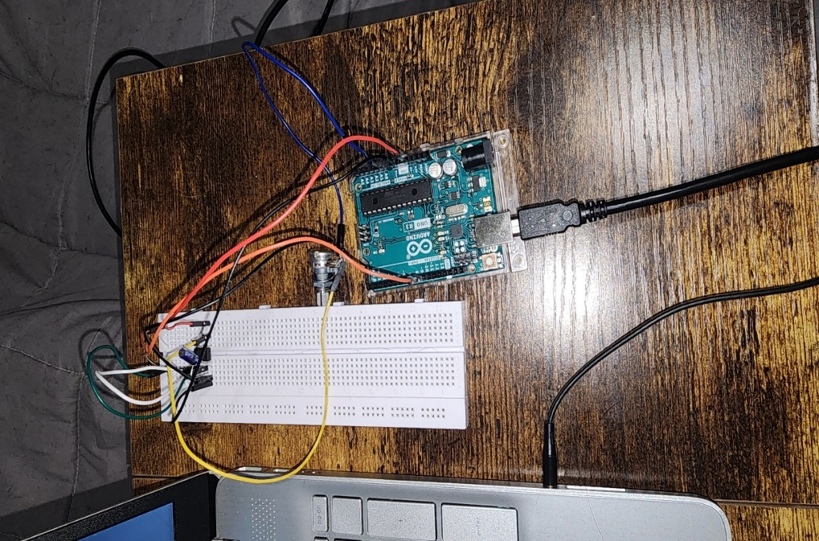

2.2 Quantifying PWM
Use the Arduino program AnaloginOutSerial to generate a PWM signal from the potentiometer and convert the PWM to a DC signal using the PWM to DC converter circuit. Insert screenshots of three levels of PWM and the corresponding DC output from the op amp. Calculate the DC level from the timing of the PWM for each case and compare to your measurement (30 points).

Dc=(Ton/Total Time)*100
DC Level=(Dc/100)*Vsupply

Smallest
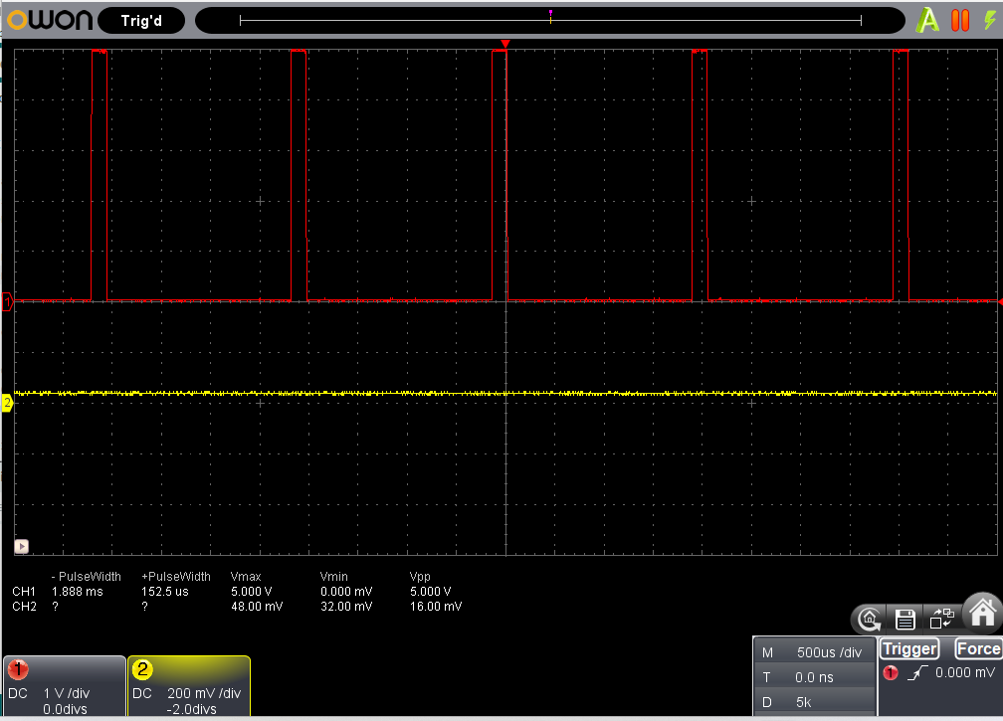
Ton=152.5um Total Time=2.04ms Vsupply=1V DC measured=75mV
Dc=(152.5*10^-6/0.00204)*100= 7.475
DC Level=(7.457/100)*1= 0.07457V or 74.6mV

Middle
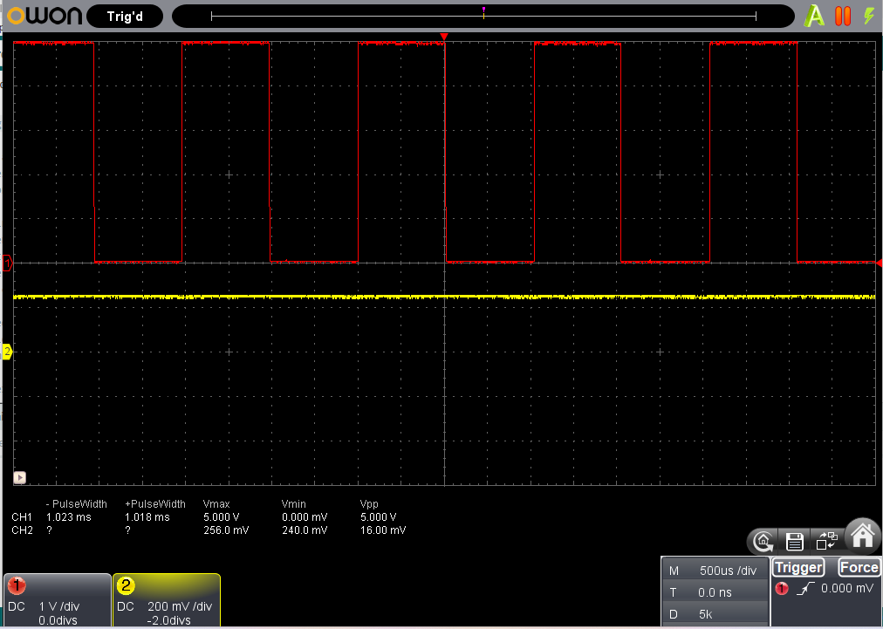
Ton=1.018ms Total Time=2.04ms Vsupply=2.5V DC measured=1.251V
Dc=(1.018*10^-3/0.00204)*100= 49.902
DC Level=(49.902/100)*2.5= 1.24755V

Largest
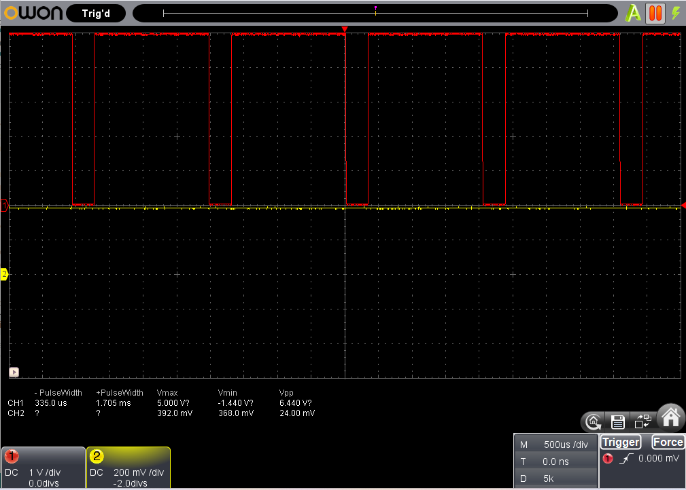
Ton=1.705ms Total Time=2.04ms Vsupply=4V DC measured=3.452V
Dc=(1.705*10^-3/0.00204)*100= 83.578
DC Level=(49.902/100)*4= 3.343V

All calculations appear close to the actual measured DC levels, while the lower the supply voltage the closer the actual and measured are.

3.1 Python Coding
Write code to print every other prime number between 1 and 100 to your screen. Insert a screenshot of your code (20 points) and a screenshot of the output (10 points)
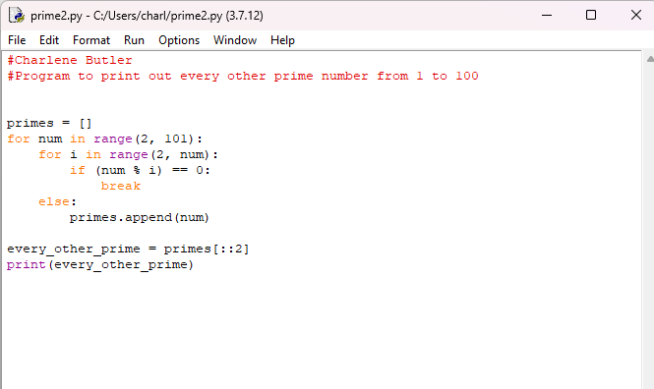

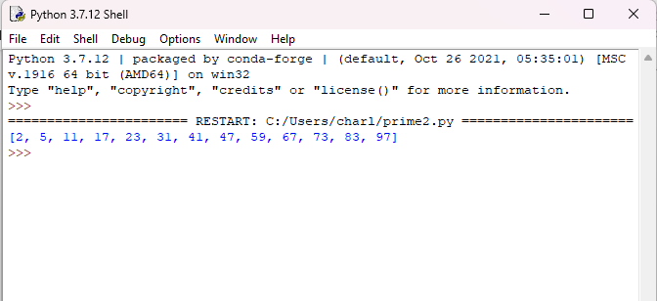

3.2 Using Python Programs
Submit screenshots of successful runs of Statistics.py and PlotandFitV2.py. Include both the fitted graph and the resulting covariance matrix elements (20 points)

